**Khulna University of Engineering and Technology**

**Department of Computer Science & Engineering**



**“Homework Manager”**

Internet Programming Laboratory

Course No – CSE 2200

|  |
| --- |
| **Developed by:**  Shubhashis Karmakar - 1107001 |
| **Supervised by:**  1.Dr. Md. Aminul Haque Akhand  Professor,CSE,KUET  2.G. M. Mashrur-E-Elahi  Assistant Professor,CSE,KUET |

|  |
| --- |
|  |

**Acknowledgement**

First and foremost, praises and thanks to Allah, the Almighty, for His showers of blessings throughout the entire time during the development of this project.

We want to thank our supervisor Dr. Md. Aminul Haque Akhand sir and G. M. Mashrur-E-Elahi sir for their great support during this project. It would have been impossible to do this project without their advices. They showed us the proper direction during the whole time and it helped me a lot in completing this project successfully.

I want to thank our seniors too for their useful advices during the project.

Any kind of suggestions or criticisms will be highly appreciated.

**Overviews**

* Introduction………………………………………………………………………………………………………………………03
* Objective…………………………………………………………………………………………………………………………..03
* Design and Functionality……………………………………………………………………………………………………03
* Table of Contents………………………………………………………………………………………………………………03
* Graphical Diagram of User…………………………………………………………………………………………………04
* Graphical Diagram of Admin…………..…………………………………………………………………………………04
* Program/Web Design………………………………………………………………………………………………………..05
* Database Overview……………………………………………………………………………………………………………09
* Recommendation………………………………………………………………………………………………………………10
* Conclusion…………………………………………………………………………………………………………………………10
* References…………………………………………………………………………………………………………………………10
* Appendices………………………………………………………………………………………………………………………..10

**Introduction:**

In today’s life, there are immense importance of web site development. In this era of digital revolution websites plays vital role in enhancing connection among the people of the world. The websites has become important resource and attached in many aspects of our life such as education, employment, government, commerce, health care and more. Now a days, websites becomes an interactive platform that is used for receiving information as well as providing information.

ASP.NET is a development framework for building web pages and web sites with HTML, AJAX, CSS, JavaScript and Server Scripting. It’s a sophisticated and powerful web development framework. It’s a server-side technology for developing web application based on the Microsoft .NET Framework.

**Objectives:**

* I have built a website for managing the homework of a classroom easily. In the class we are often given assignments and homework. We cannot submit the homework any time within the given submission time. We have to come to the classroom then submit the homework. Sometimes the PCs are affected with viruses and malwares and we face a lot of difficulty. By submitting the homework on the LAN any one can copy others homework and resubmit it by their name. In the project I have simplified the process and added a security so that no one can copy others work.
* So the website will both help the teachers and students for better managing the homework and assignment. Also unwanted members will be prohibited as there is an admin of the group who will control the members who join the group.

**Design and Functionality:**

Homework Manager Website is designed both for the feasibility of the Teachers and Students. The website has two main interfaces, one for teachers and students other one for the admin.

**Table of Contents:**

1. Graphical Diagram of the User(Teacher and Students)
2. Graphical Diagram of the Admin
3. Database overview

**Graphical Diagram of User: (Teacher and Student)**

From a user perspective, Homework Manager has the basic structure like any website for the user feasibility. This is illustrated by the following block diagram:

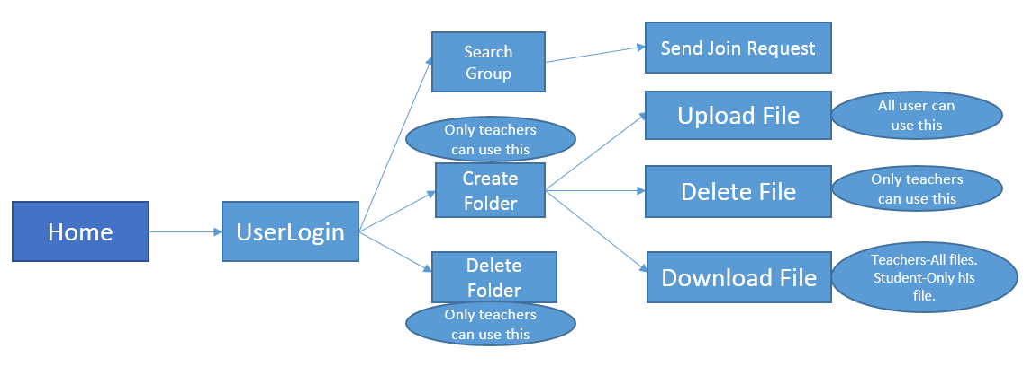

The User Page consists of the following items:

***Search Group****:* Here all users can search for a group and send join request if the group exists.

***Create Folder****:* Here only the teacher can create an empty Folder

***Delete Folder****:* Here only the teacher can delete an entire folder

***Upload File****:* Users can upload file as long as there is time to submit. If the submission time is over user cannot upload.

***Delete file****:* Only Teacher can delete the uploaded file.

***Download File****:* Only the Teacher can download all files. Students are allowed to download their files only. So they cannot download files of others.

**Graphical Diagram of Admin:**

From an admin perspective, Homework Manager has the basic structure like any website for the admin feasibility. This is illustrated by the following block diagram:

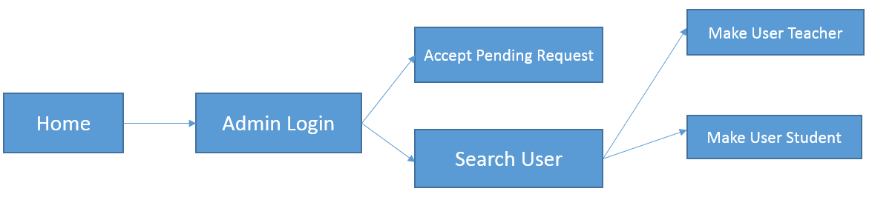

The Admin Page consists of the following items which has different functionality according to its uses.

***Accept Pending Request****:* Here the admin can accept the join request sent to the group.

***Search User****:* Here the admin can search for a user and make the user teacher or student of the group.

**Program/Web Design:**

* ***Home.aspx:*** A web page to display the homepage, login, register and create group option.(Fig 1)
* ***UserPage.aspx:*** It’s a web page after login by the user(Fig 2)
* ***FindGroupPage.aspx:*** In the page in which the user finds group and send request to group.(fig 3)
* ***GroupPage.aspx:*** It’s a page which displays the folders in the group(Fig 4)
* ***InsideFolder.aspx*:** It’s a page which displays the files in the group(Fig 5)
* ***AdminPage.aspx:*** It’s the page for the admin of the group.(Fig 6)
* ***FilterPage.aspx:*** In the page the admin searches for a user and make the user teacher or student.(Fig 7)
* ***CreateGroup.aspx:*** One can create a group in this page. He will be the admin of the group. AJAX is implemented here. So duplicate group creation won’t be possible.(Fig 8)
* ***Register.aspx:*** One can register as student or Teacher in this page. AJAX is also implemented here. So Duplication is not possible. (Fig 9)
* ***Popup.ascx:*** Teacher can create a folder here. AJAX is implemented to check if the folder exists. JQuery is used here (Fig 10)
* ***UploadPopup.ascx:*** It’s a Popup which lets the user to upload a file. JQuery is used here (Fig 11)

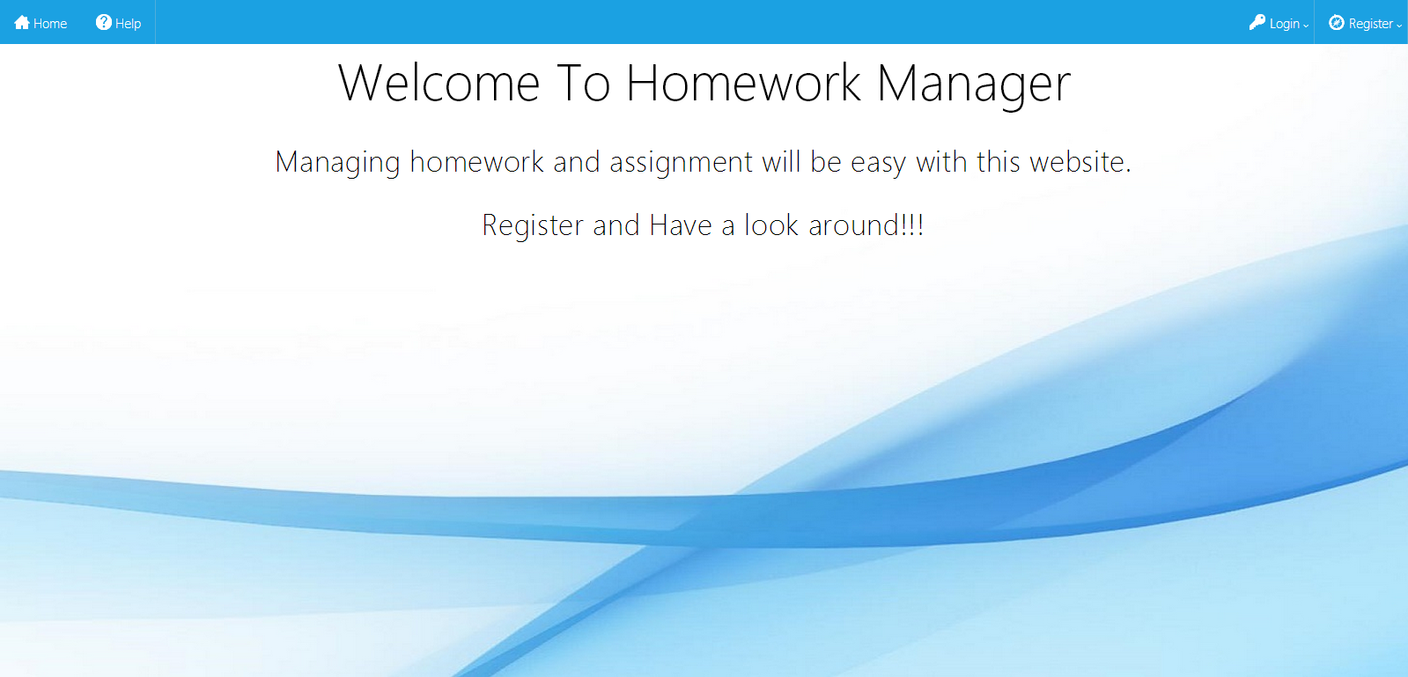

Fig 1: Home Page

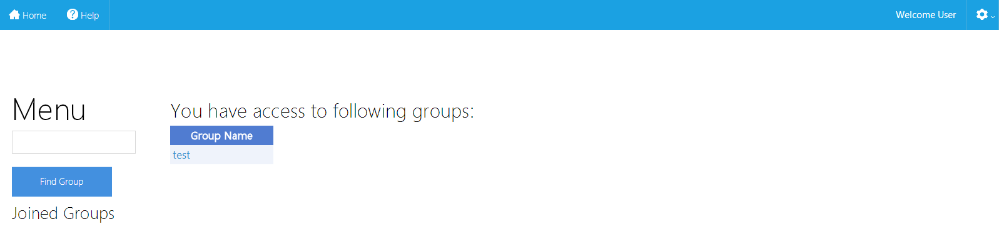

Fig 2: User Page

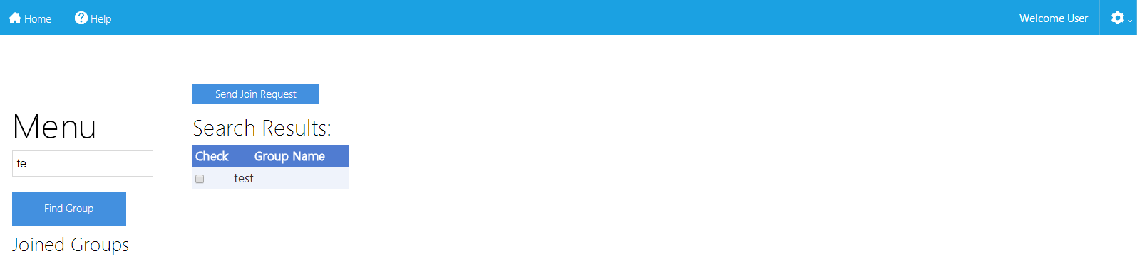

Fig 3: Find Group Page

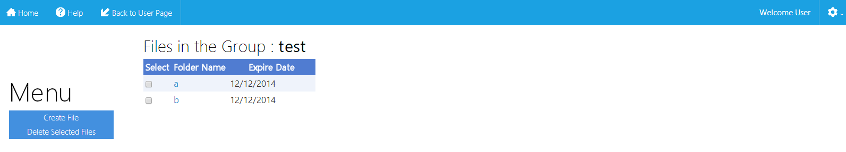

Fig 4: Group Page

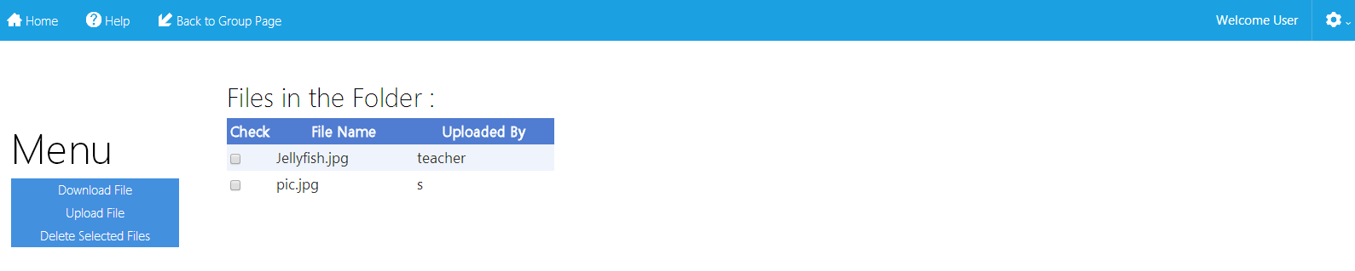

Fig 5: Inside a Folder Page

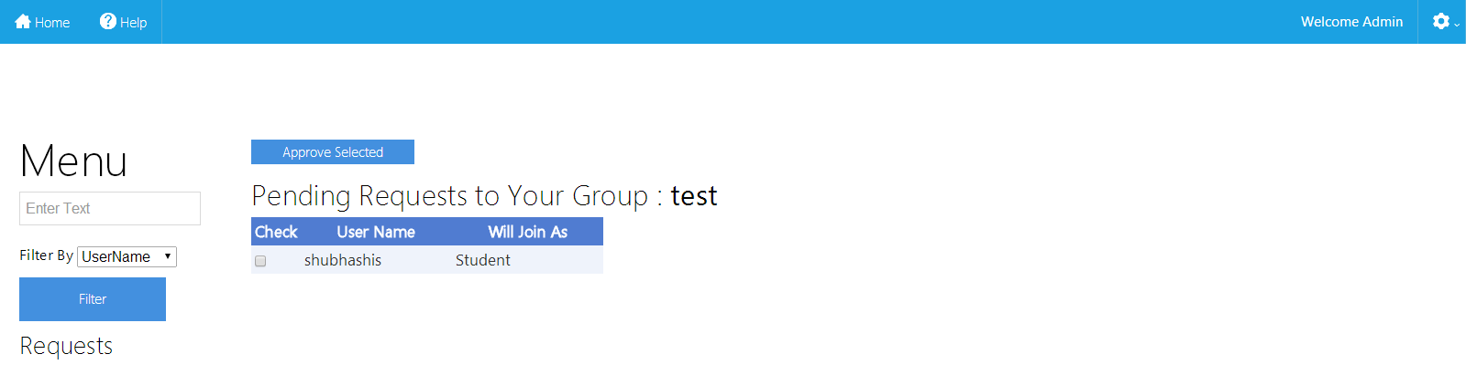

Fig 6: Admin Page

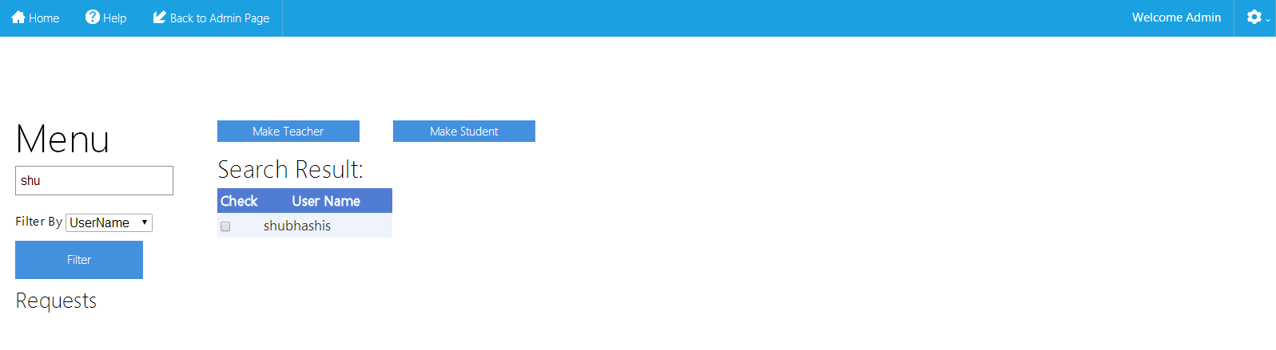

Fig 7: Filter Page

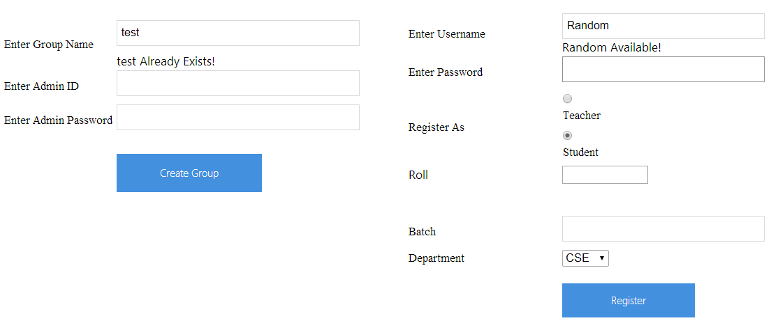

Fig 8: Create a Group Fig 9: Register as User

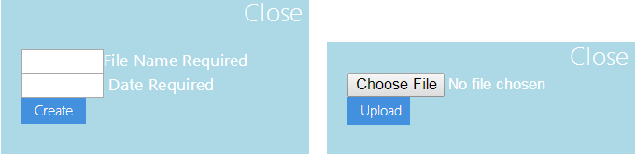

Fig 10: Create a Folder Fig 11: Upload a File

**Database Overview:**

I have implemented a Microsoft SQL Server Database for storing the User list, Group List, Folder list, File List, Request list.

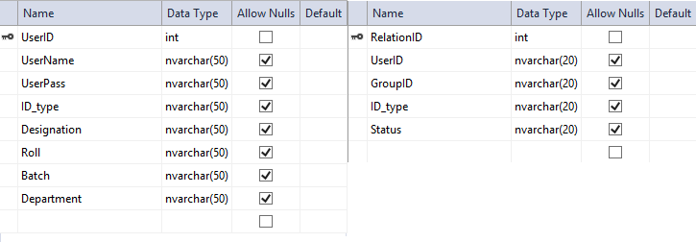

Fig: UserTable Fig: RelationTable

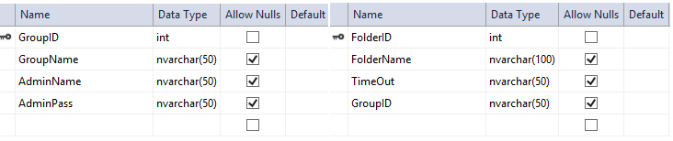

Fig: GroupTable Fig: FolderTable

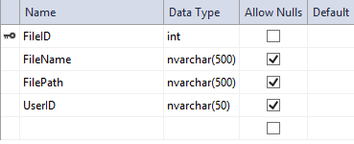

Fig: FileTable

**Recommendation:**

* This website can be upgraded by adding comments of the user to each of the files. Student can also chat with Teacher to solve anything from the website.

**Conclusion:**

It had been a challenging task to develop a website on visual studio in ASP.NET .I was focused to my objectives and as a result of fact I managed to complete the project. My primary objective was to create a file management system and create a restriction system among the users. I was able to fulfill this task with user friendly interfaces.

**References:**

1. [**http://www.w3schools.com/**](http://www.w3schools.com/)
2. [**http://www.asp.net/**](http://www.asp.net/)
3. [**http://stackoverflow.com/**](http://stackoverflow.com/)
4. [**https://api.jquery.com/category/ajax/**](https://api.jquery.com/category/ajax/)
5. [**http://html.net/tutorials/asp/**](http://html.net/tutorials/asp/)
6. [**http://www.tizag.com/aspTutorial/**](http://www.tizag.com/aspTutorial/)

**Appendices:**

We provide here a fragment of code that constitutes the main part of our project, namely file upload and download. We omit the entire source code because of space limitation.

|  |
| --- |
| protected void UploadButton_Click(object sender, EventArgs e)  {  string GroupName = (string)Session["grpName"];  string FolderName = (string)Session["Foldername"];  string UserName = (string)Session["UserName"];  if (FileUploader.HasFile)  try  {  string path = Server.MapPath("~");  string fileName = FileUploader.FileName;  path += "FileStorage" + "\\" + GroupName + "\\" + FolderName + "\\" + fileName;  string pathdb = "FileStorage" + "\\" + GroupName + "\\" + FolderName + "\\" + fileName;    FileInfo file = new FileInfo(path);  if (!file.Exists)  {  if (FileUploader.PostedFile.ContentLength > 26214400)  {  Label1.Text = "Maximum File Upload size 25MB";  ShowPanel();  }  else  {  FileUploader.SaveAs(path);  string connectionString = ConfigurationManager.ConnectionStrings["ConnectionString"].ConnectionString;  SqlConnection conn = new SqlConnection(connectionString);  conn.Open();  SqlCommand unamecomm = new SqlCommand("select UserID from UserTable where UserName = '" + UserName + "'", conn);  SqlDataReader userNameReader = unamecomm.ExecuteReader();  userNameReader.Read();  string UserID = userNameReader["UserID"].ToString();  userNameReader.Close();  SqlCommand comm = new SqlCommand("Insert into File_Table(FileName,FilePath,UserID) Values('" + fileName + "','" + pathdb + "','" + UserID + "')", conn);  SqlDataReader reader = comm.ExecuteReader();  reader.Close();  Response.RedirectPermanent("InsideFolder.aspx?FolderName=" + FolderName + "");  }  }  else  {  Label1.Text = "File Exists";  ShowPanel();  }  }  catch(Exception ex)  {  }  else  {  Label1.Text = "Choose a File";  ShowPanel();  }  } |

|  |
| --- |
| protected void DownloadFileButton_Click(object sender, EventArgs e)  {  string loginstate = (string)Session["loginstate"];  if (loginstate != "1")  Response.RedirectPermanent("Home.aspx");  for (int i = 0; i < FileGridView.Rows.Count; i++)  {  CheckBox chk = (CheckBox)FileGridView.Rows[i].FindControl("FileCheckBox");  if (chk.Checked == true)  {  string FileName = FileGridView.Rows[i].Cells[1].Text.ToString();  string Uploader = FileGridView.Rows[i].Cells[2].Text.ToString();  string path = Server.MapPath("~");  path += "FileStorage" + "\\" + GroupName + "\\" + FolderName + "\\" + FileName;  FileInfo file = new FileInfo(path);  if (IDtype == "Student" && UserNameSession != Uploader)  AbilityLabel.Text = "No Permission to Download";  else if(file.Exists)  {  Response.Clear();  Response.ClearHeaders();  Response.ClearContent();  Response.AddHeader("Content-Disposition", "attachment; filename=" + file.Name);  Response.AddHeader("Content-Length", file.Length.ToString());  Response.Flush();  Response.TransmitFile(file.FullName);  Response.End();  }  }  }  } |